Artifact registry

# Introduction:

In this section we will create, build and push the image to the artifact registry.

## Step one:

Create your python code.

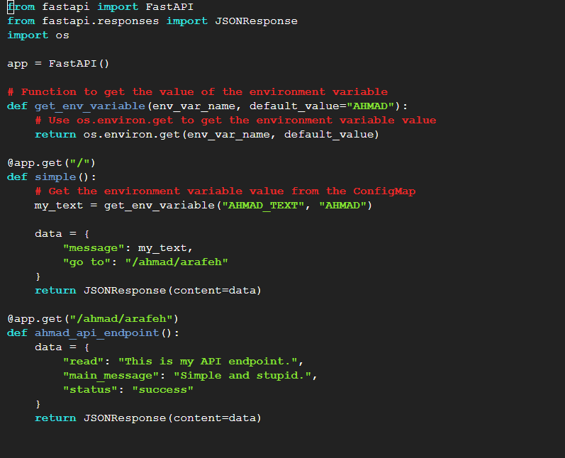

Then create your docker file:

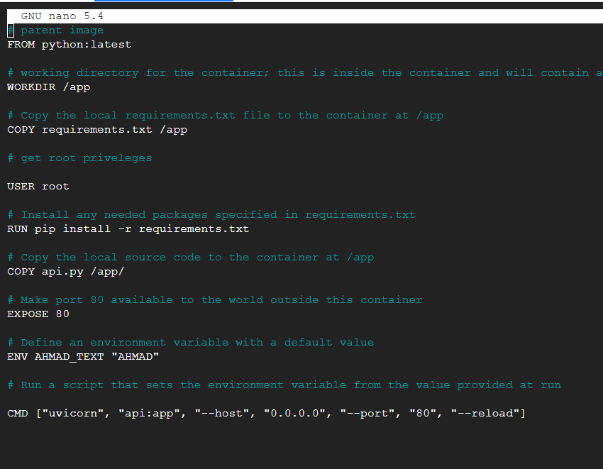

Create your requirements.txt file:

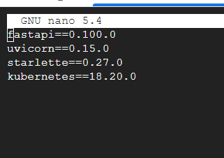

## Step 2:

First enable the API of the artifact registry:



After you enable the API build your image:

Then you need to tag and push the image, to do that correctly go to the artifiact registary create a repostary and copy the repostary path:

Copy the path:

After that tag the image and push the image with the path and the name of the image:

And then we can see the image here:

SIMPLE AND STUIPD!